i). Identify the advantages and disadvantages of the Selective Repeat ARQ flow control technique.

ii). Given Scenario:- Sender1 has received an ACK from receiver1 and Sender2 has not received an ACK from receiver2 in a LAN that uses Go-Back ARQ for flow control. Find out and narrate various changes/actions that happened at computing nodes Sender1, Sender2, Receiver1, and Receiver2.

i). Analyse and justify the needs of subnetting with respect to network traffic.

ii). In a campus network, an ip address 130.10.10.7 has been used for broadcasting common messages.

i. Find out how many routers are required to design the campus network.  
ii. How many sub-networks are there in the campus network?  
iii. How many bits will be borrowed from the host part?  
iv. Compute the custom subnet mask.  
v. In every possible sub-net, identify the network address, broadcast address, first host address, last host address, and a total number of usable host addresses.

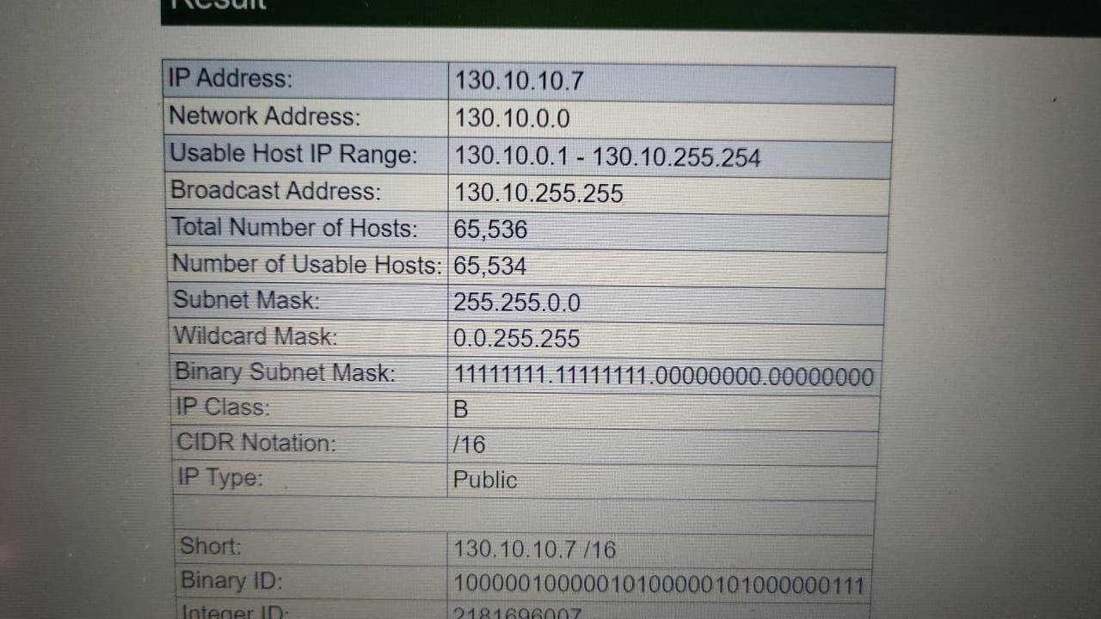

i). Analyse and justify the needs of subnetting with respect to communication cost.

ii). In a campus network, an ip address 10.10.10.15 has been used for broadcasting common messages.  
i. Find out how many routers are required to design the campus network.

ii. How many sub-networks are there in the campus network?

iii. How many bits will be borrowed from the host part?  
iv. Compute the custom subnet mask.   
v. In every possible sub-net, identify the network address, broadcast address, first host address, last host address, and a total number of usable host addresses.

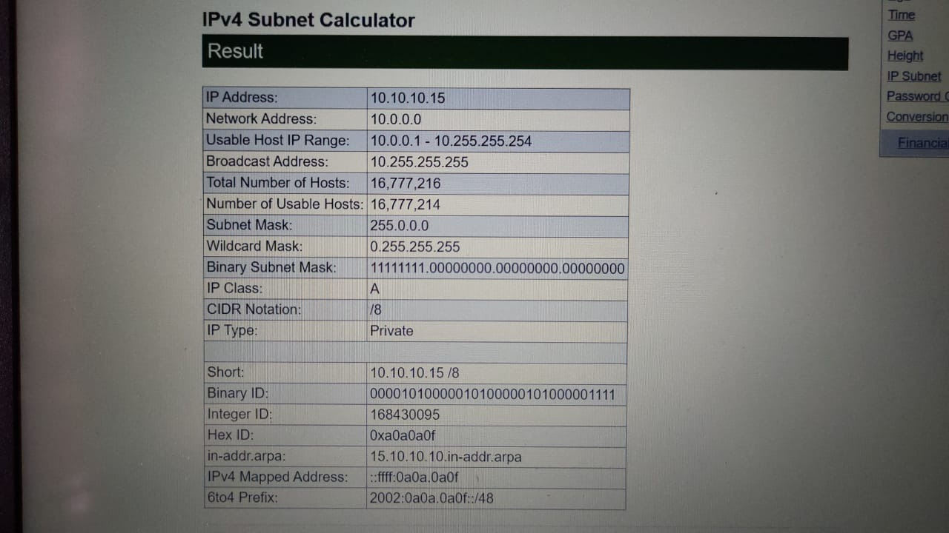

Illustrate the workings of the Dijkstra algorithm using a suitable flowchart and apply the same on the given graph to find the first best shortest path and next best shortest path from node-A to node-F.

Analyze your results and give your thought on which path is optimal with sufficient justifications.

